Please submit this invention report at [https://imt.ad.here.com](https://imt.ad.here.com/" \t "_blank), and if you have difficulties in submitting the invention report, you can email it to [ipr.inventions@here.com](mailto:ipr.inventions@here.com" \t "_blank).

# TITLE OF THE INVENTION:

|  |
| --- |
| A sub-centimeter scalable odometry solution |

# Inventor details

Please note that each person who made a contribution to the invention must be named as an inventor in this section.

(There needs to be a separate agreement between HERE and the employer of the external inventor (please specify the details below in the “Joint inventions” section).

Please consult the HERE Patenting Team with additional questions.

|  |  |  |  |  |
| --- | --- | --- | --- | --- |
| **HERE Inventor name**  (Surname, given name(s); Chinese inventors, please add your name also in Chinese characters and identify which name is your family name and your given name(s)) | **HERE ID** | **Home address\* and personal email**  **MANDATORY** | **Nationality\*\*** | **Employer at the time of the invention** |
| Neel Shah | 25649 | 1423 Ninth St  Berkeley, CA 94710 | USA | HERE NA LLC |
| Kenneth Laws | 39512 | 2150 Woolsey St  Berkeley, CA 94705 | USA | HERE NA LLC |
| Christian Cheetham | 36441 | San Francisco, CA 9xxxx | USA | HERE NA LLC |

|  |  |  |  |
| --- | --- | --- | --- |
| **Non-HERE Inventor(s)**  (Surname, given name(s); Chinese inventor, please add your name also in Chinese characters and identify which name is your family name and which your given name(s)) | **Home address\* and personal email**  **MANDATORY** | **Nationality\*\*** | **Employer** |
|  |  |  |  |
|  |  |  |  |

\*Your home address and personal email address are necessary for the HERE Patenting team to keep on-file for two reasons. First, if you separate from HERE, the Patenting team will need a way to communicate with you (e.g., for patent payments, questions, etc.). Also, the home address is oftentimes part of patent application filings; however, you should know that your home address will be used in a potential patent application and may become public via some patent offices. If you do not want your home address to be used in a potential patent application, please give your office address, indicating the HERE entity and that the address is your office address.

\*\*Nationality information from inventors is needed for patent applications in certain countries.

# Joint inventions (with other company or subcontractors)

|  |  |
| --- | --- |
| Company name, address, email & contact person: |  |
| Project and/or agreement number and link to the agreement: |  |
| HERE contact person: |  |

# Has the idea already been discussed with someone in the HERE Patenting team? For example, have you had an informal discussion about the idea with a patent engineer/attorney or has a patent engineer/attorney made a pre-screening search on your idea? If yes, please indicate the name of the person.

[No

# Field of technology and background of the invention Describe the technology and the areas of use the invention relates to. Provide general background knowledge that is required to understand the framework of the invention. Leave a description of a problem to be solved and the invention in the subsequent paragraphs.

[ The technology field in which this invention is applicable is in hardware sensing and software algorithms that interpret sensor results. The invention relates specifically to the measurement of vehicle speed and translational motion. We leverage both visual and infrared domains of optical engineering to create a novel solution to measuring vehicle speed and rate of change of direction. Our solution also addresses scalability and the relatively easy installation and deployment of our odometer relative to other solutions.

# Problem Describe the problem that the invention solves or the situation that the invention improves. Mainly concentrate on the technical aspects of the problem or the situation.

[ Developing highly accurate maps requires a highly accurate position from which data is collected about the world. The HERE True system features high resolution cameras and laser scanners to develop beautiful imagery and rich feature density that is built into the company’s map offerings. However without a highly accurate positioning system these images and features are still not guaranteed to be accurately placed. This is a problem facing all mapmakers, autonomous vehicles, cell phones, etc. that are reliant on GPS and a suite of accelerometers and gyroscopes to determine position. GPS signals can be intermittent to non-existent in a variety of situations, from canyons to highways to tunnels, and accelerometer error increases rapidly over a short period of time without a proper GPS signal to continuously calibrate its readings. Highly accurate vehicle odometry is a promising solution to solve this problem.

# Current state of technology Describe how the problem was solved earlier or the current state of technology that is causing the problem described above in section 2. Please state also the source of prior art accurately (literature references, patent numbers, URLs etc). In case of a non-patent reference, please attach a copy of it in your submission, if possible.

[ The most common implementations of obtaining vehicle odometry are also unreliable or difficult to implement at scale. The standard is a wheel encoder, a device that attaches to the outside or inside of a wheel and counts the number of revolutions of a wheel. It emits pulses each time the tire moves beyond a certain angle of rotation. The error from measurements in such a device are quite high, ranging from 3-5% based on variables like tire pressure, turning angle, and road roughness. In addition specific information is needed about the vehicle on which it is mounted, and some countries explicitly ban its use. The installation procedure is extremely invasive and time consuming, and different models are needed for different vehicles.

Another implementation of vehicle odometry is CAN bus hacking. In fact HERE currently leverages this method of obtaining vehicle odometry. Vehicle odometry measurements are output on the OBDII port as part of the 1996 OBD specification; however, this specification is voluntary and vehicle manufacturers are not required to comply with it; they may or may not implement this field as they wish. This creates difficulty for mapping companies which need to flexibly operate on a variety of vehicles to collect map data. In addition the latency of data is unknown; it is impossible to say with certainty when exactly that vehicle velocity was taken and published to the CAN bus. Finally the vehicle velocity published on the CAN bus is measured in a manner similar to the wheel encoder described above; it is dependent on vehicle specific factors that are difficult to keep track of across a large fleet, and limits its scalability.

The most relevant prior art we have found is patent # US 20040221790 A1, Method and apparatus for optical odometry. This patent describes technology very similar to the invention proposed here, that is, determination of vehicle translation using sequential optical imagery.

# Brief summary of the invention Crystallize the invention in few sentences. Concentrate on technical features and describe on a general level how the invention is different from the prior art.

[ The invention employs, at a minimum, a single optical (or infrared) image sensor combined with a data collection/data processing hardware and a software algorithm to generate a more precise estimate of position and motion than is otherwise possible. Additional elements may include a short range precision range-finder, an illumination lamp (LED), or an additional image sensor. The invention uses high speed sequential imagry to determine vehicle translationover the imaged roadway. An algorithm runs on an attached computer that performs image registration to produce a highly accurate velocity estimates. With the exception of US 20040221790 A1, the prior art described above only captures speed and not direction. Additionally this sensor package is easy to install potentially using a tow hook or license plate bracket mounting.

It is not clear at this time what features exist that differentiate this invention from US 20040221790 A1, apart from there being little or no discussion in the patent of the algorithm used to process data or how to achieve performance at high vehicle speeds. The above patent is focused on low speed applications such as agricultural and robotics applications. In our present state of the invention we have obtained data from a prototype and retrieved vehicle speed up to approximately 60 mph.

# Detailed description and implementation of the invention Describe exemplary technical implementations in detail with alternatives, including at least the implementation you consider the best. Describe the crucial elements in detail. Include figures, flowcharts, signalling diagrams, device, architecture and UI presentations etc. Spell out any abbreviations used.

[ The invention, in its present state of development employs a single optical imaging device, and a computer for data collection and processing. The invention is currently in prototype form with data processing functional post collection. The system is described in the bloc diagram, Fig 1.

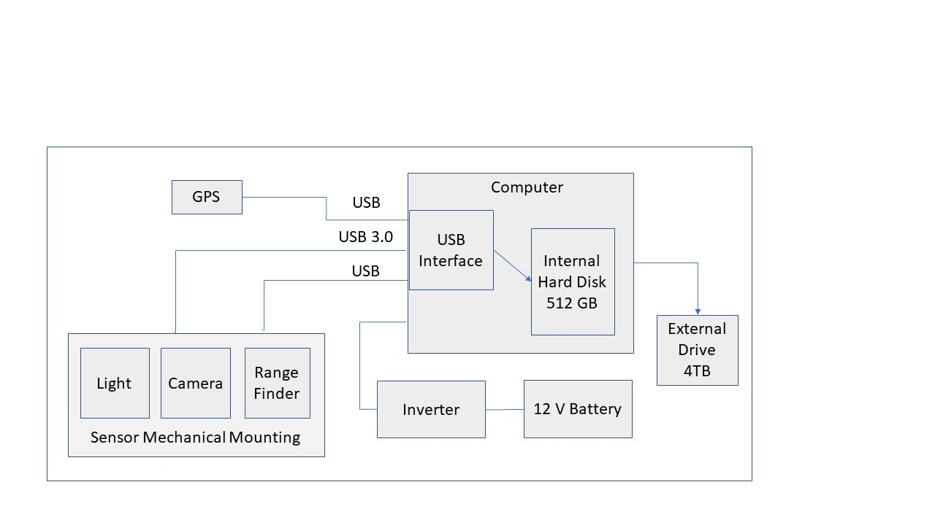

Fig. 1. Block diagram of optical odometer system prototype

In its simiplest configuration, shown in Fig. 1. the invention employs a high frame rate, high resolution camera pointed down, perpendicular to the road surface. Images are recorded at a sufficiently high frame rate so that there is enough overlap of sequential images to perform image registration at the desired highest operational speed of the vehicle. For Here mapping vehicles this speed is approximately 130 km/hr. The computer may already be present in the vehicle (used for mapping rig sensor data collection) or dedicated to the proposed invention.

The GPS may be cell phone-based or other standard resolution unit or in a preferred arrangement, a high resolution unit employing RTK or other corrections. The invention supplies highly accurate measurements of vehicle translation per unit time (time between images). The image timeing is kept by digital methods, either by frame rate set by the camera or by the host computer to sufficient accuracy to enable vehicle speed estimation with the same relative accuracy as the translation measurements. The translation measurements can be combined with the GPS measurements to provide position measurements with absolute reference during lapses of GPS data availability.

In a basic configuration a rangefinder is not strictly needed, but in a preferred arrangement provides data for real time continuous calibration. Calibration of translation measurements requires accurate calibration of camera height above roadway. Range finder calibration data can compensate for changes in vehicle loading or changes in tire pressure that affect the height of the camera above the road. Reangefinder measurements also can be used to make the instrument “self calibrating” and eliminate the need to measure the camera mounting height carfully after intial installation or removal and repositioning of the camera mounting unit, e.g., if the unit is removed when the vehicle is not in operation. In a preffered arrangement the rangefinder has a high enough data rate to supply corrections in calibration that can be time synced with the image data to correct for changes in instrument height above roadway due to vehicle bouncing.

In the simplest configuration an external light source is not necessary for daylight operation. In a preferred arrangement a light is provided to mitigate the effect of shadows on the image, including shadows caused by the vehicle itself. If a mounting configuration that positions the sensors at the front of the vehicle is used, white lighting may be used. If the camera is located at the rear of the vehicle, red or amber lighting would be used for legal reasons relating to safety of other drivers. In any case, lighting is directed down onto the imaged area and shaded from other directions by mechanical means.

, positioned near the front or rear bumper

# Advantages and disadvantages Describe how the invention improves earlier solutions. If you are aware of any technical advantages or disadvantages, please state them here.

[ There are two distinct advantages our odometry solution provides above all other presently existing solutions. The first concerns installation: our sensors are easily mounted to pre-existing locations on a vehicle. The mounting components are simple to manufacture and the sensor package is not sensitive to minor variations in installation angle, orientation, etc. The second concerns the precision and utility of the measurement: adding a laser rangefinder to a visual odometer produces accurate velocities in all three spatial dimensions, as well as an accurate rotation estimate, where prior art only produces a scalar speed value.

The disadvantage of our solution, which is shared among all visual odometry solutions, is the volume of data that is generated and analyzed. With a high speed data bus and a reasonably powerful computer these issues are mitigated; these are non-issues with our mapping equipment but prevent their deployment in, say, a scooter or bicycle.

# Supervision Explain how we can (if possible) recognize if a competitor is using the same product/feature.

[

The invention is:

X Easy to detect (e.g., obvious, use of the invention can be noticed in everyday use)

* Somewhat difficult to detect (e.g., requires test tools, opening of product, use of SW development kit)
* Difficult to detect (e.g., requires reverse-engineering of SW object code or IC operation)

# Implementation, standard relevance, experts and further comments You can indicate in this section if you know about plans to implement the invention in products or to contibute to a standard, if you consider the invention to require further development, know of a related earlier invention report in HERE by you or others, or have any additional information that you think may otherwise affect the decision process. Please list some experts capable of commenting on the invention, if known.

[ We intend to deploy this invention as part of the Here True fleet upgrade in 2018. This invention requires further development prior to its release.

1. **Publication/Public use/Sale**  
   if the invention is becoming public in any way, please describe the exact way and details of the publication: what will be disclosed, how and when. For example, submission of standardization contributions, scientific papers, conference abstract, theses or papers written for a degree and commercial brochures and offers for sale may be considered as publication. Also, any use in a product that is publicly available or disclosure (written or oral) to another company without a non-disclosure agreement (NDA) is considered to be a publication.

In case of urgent publication, please contact the HERE Patenting Team before publishing the invention.

[ N/A

**On behalf of all the inventors, this is to confirm and acknowledge that:**

* I am/we are the sole/and original inventor(s) of this invention.
* The company may, by virtue of applicable legislation, be entitled to full or partial rights to the invention.
* I/We acknowledge my/our obligation to sign as inventor(s) all documents that may be required for protecting the invention in different countries.
* I/We hereby give my/our consent for the personal data included in this invention report to be transferred, also to countries outside the European Economic Area to the external associates of HERE to be processed and used in relation to drafting, filing and/or prosecuting the patent and/or utility model application(s) based on this invention report. Such data may become publicly available when patent/utility model application is published and/or the patent/utility model granted/issued.
* I/We acknowledge and agree that English is the company language and that all communications, notifications and agreements concerning the invention may be made in the English language.
* I/We acknowledge and agree that all communications, notifications and agreements concerning the invention may be made electronically.
* I/We have accessed and read the HERE Group Guidelines for Employee Inventions and acknowledge that they are applicable to this invention.
* HERE Invention Reports are to be filed electronically. In addition, the Inventor may wish or may be requested to file also a paper copy, signed by the inventor(s).
* The acceptance of the above statements and terms is indicated in the electronically filed HERE Invention Submission via the Invention Management Tool. Alternatively, the inventor(s) may indicate accecptance of these terms via [ipr.inventions@here.com](mailto:ipr.inventions@here.com), or send a signed invention report to HERE North America, LLC, 425 West Randolph Street, Patenting Team, Attention Debra Huffman, Chicago, Illinois 60606.
* In case the terms are not accepted, please specify the specific term(s) you wish to contest.

Date : [ 2017 – 11 – 07 ]

**Signature(s) of Inventor(s):**

**Applicable to inventions made by inventors employed in Denmark, Finland, Germany and Sweden only:**

Unless the inventor requests that this Invention Report is responded to within four (4) months from the date that it is received, or such other period as the mandatory provisions of the applicable local law may otherwise require, the inventor consents to the right of the employer to use a reasonable period of time for the evaluation of the invention. A reasonable period of time may exceed four (4) months.

X I/We request that the Invention Report be responded to within four (4) months.